1. AIM: Write a Python program to print the calendar of a given month and year.

PROGRAM:

import calendar

year=int(input())

month=int(input())

if(year<10000 and year>999 and month<13 and month>0):

print(calendar.month(year,month))

else:

print("Invalid Input")

LINK: <http://103.53.53.18/mod/vpl/view.php?id=229>

OUTPUT:

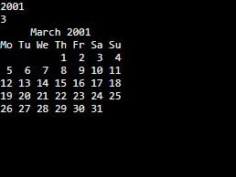

**RESULT: Thus the Python program is written and the calendar of the Month and year is Printed**